EMPLOYEE RAISE ISSUE – RECORD PRODUCER & SERVICE PORTAL INTEGRATION
PHASE 4: Creating a Record Producer

1. Introduction
This phase creates a Record Producer that allows employees to submit issues through a simple catalog-style interface. The variables are mapped to the Employee Raise Issue table so ServiceNow creates a backend record automatically.

2. Objective
To create the Raise Employee Issue Record Producer and map its variables to the custom table.

3. Creating the Record Producer
1. Navigate to All → Service Catalog → Catalog Definition → Record Producers.
2. Click New.
3. Set Name to Raise Employee Issue.
4. Set Table to Employee Raise Issue.
5. Enter a suitable description.
6. In Accessibility, select Service Catalog.
7. Select Service as the Category.
8. Add an image in Picture if required.
9. Provide the table name as the Meta value where applicable.
10. Save the Record Producer.
Raise Employee Issue Record Producer configuration
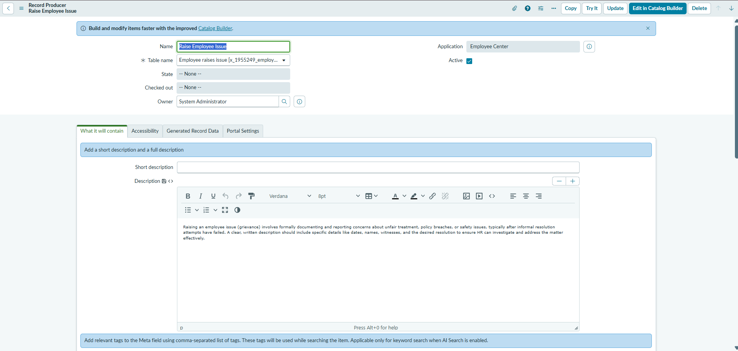
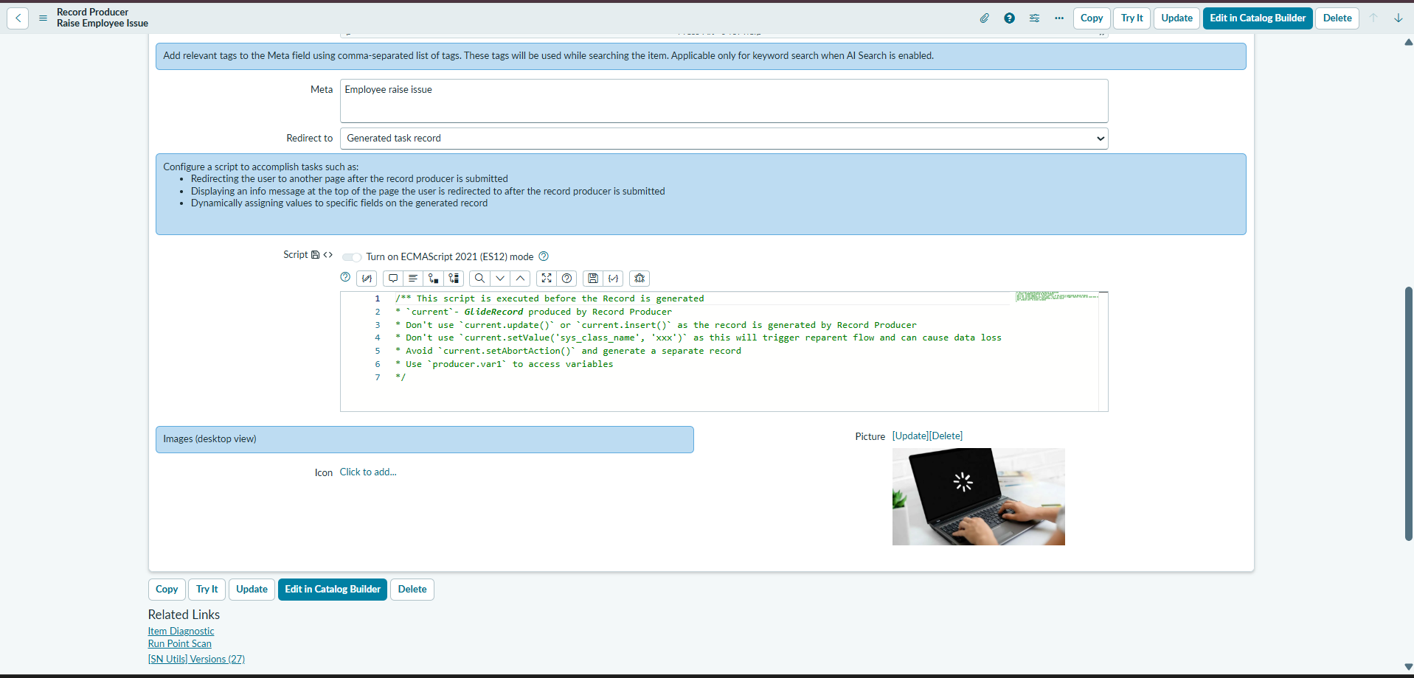

4. Creating and Mapping Variables
1. Open the Variables related list and click New.
2. Choose the required variable type.
3. Enable Map to Field.
4. Select the corresponding Employee Raise Issue field.
5. Set order values as 100, 200, 300, 400, and 500.
6. Enter the question text.
7. Save each variable.
Variable | Type | Configuration
Requester name | Reference | sys_user
Category | Choice | Network, Software, Hardware, Access
Subcategory | Choice | VPN, Laptop, Server, Forgot password
State | Choice | New, In progress, Resolved, Closed
Short description | Single Line Text | Issue summary
Record Producer Variables related list
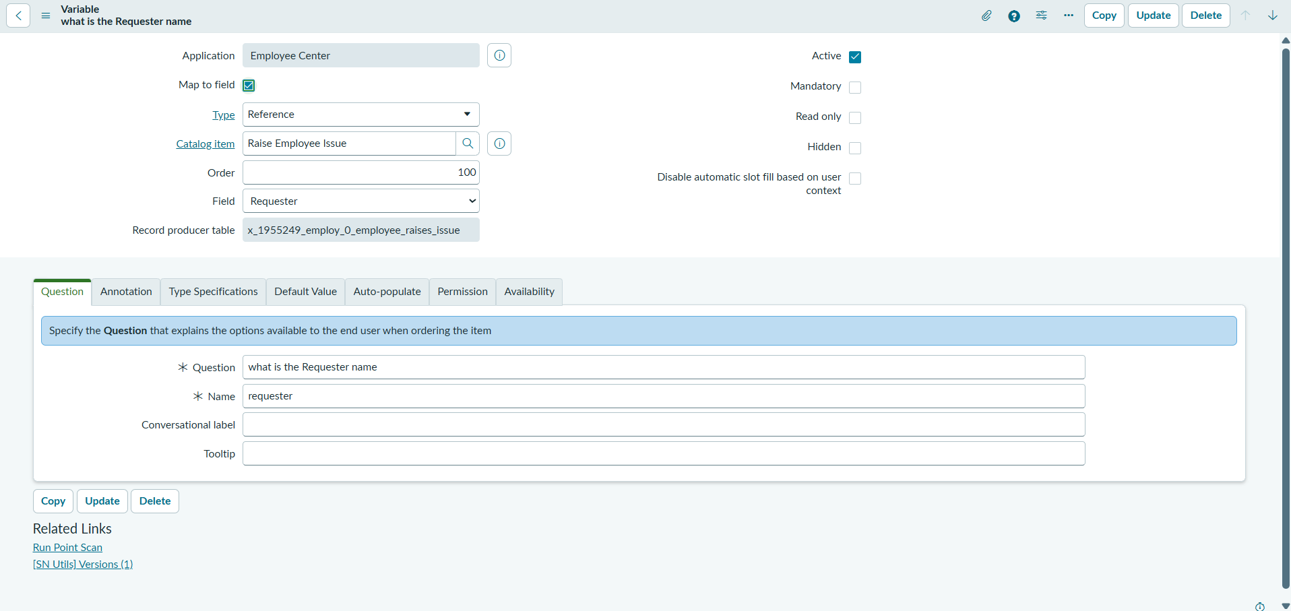
Variable mapping to Employee Raise Issue fields
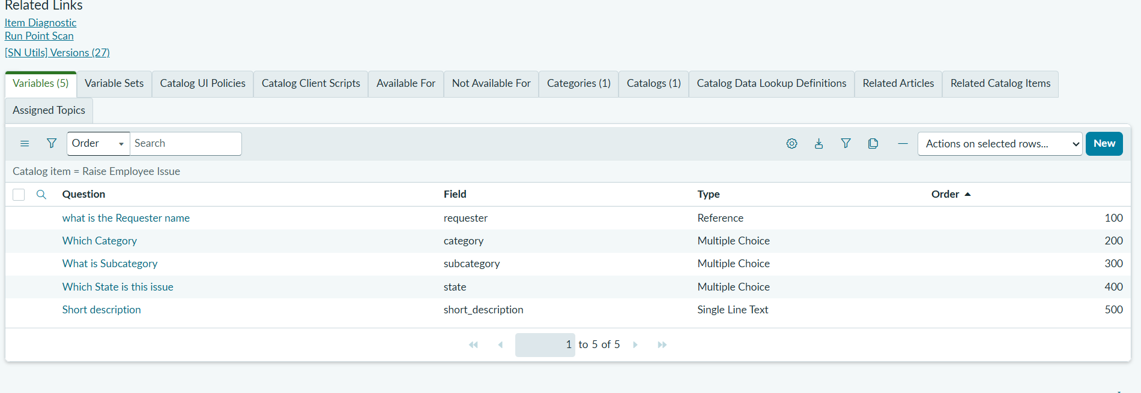

5. Portal Verification
1. Open the ServiceNow instance in a new browser tab.
2. Add /sp to the instance URL.
3. Search for the Employee Raise Issue request.
4. Open Raise Employee Issue.
5. Fill in the variables and submit.
6. Verify that a corresponding Employee Raise Issue record is created in the backend table.
Raise Employee Issue Record Producer in Service Portal

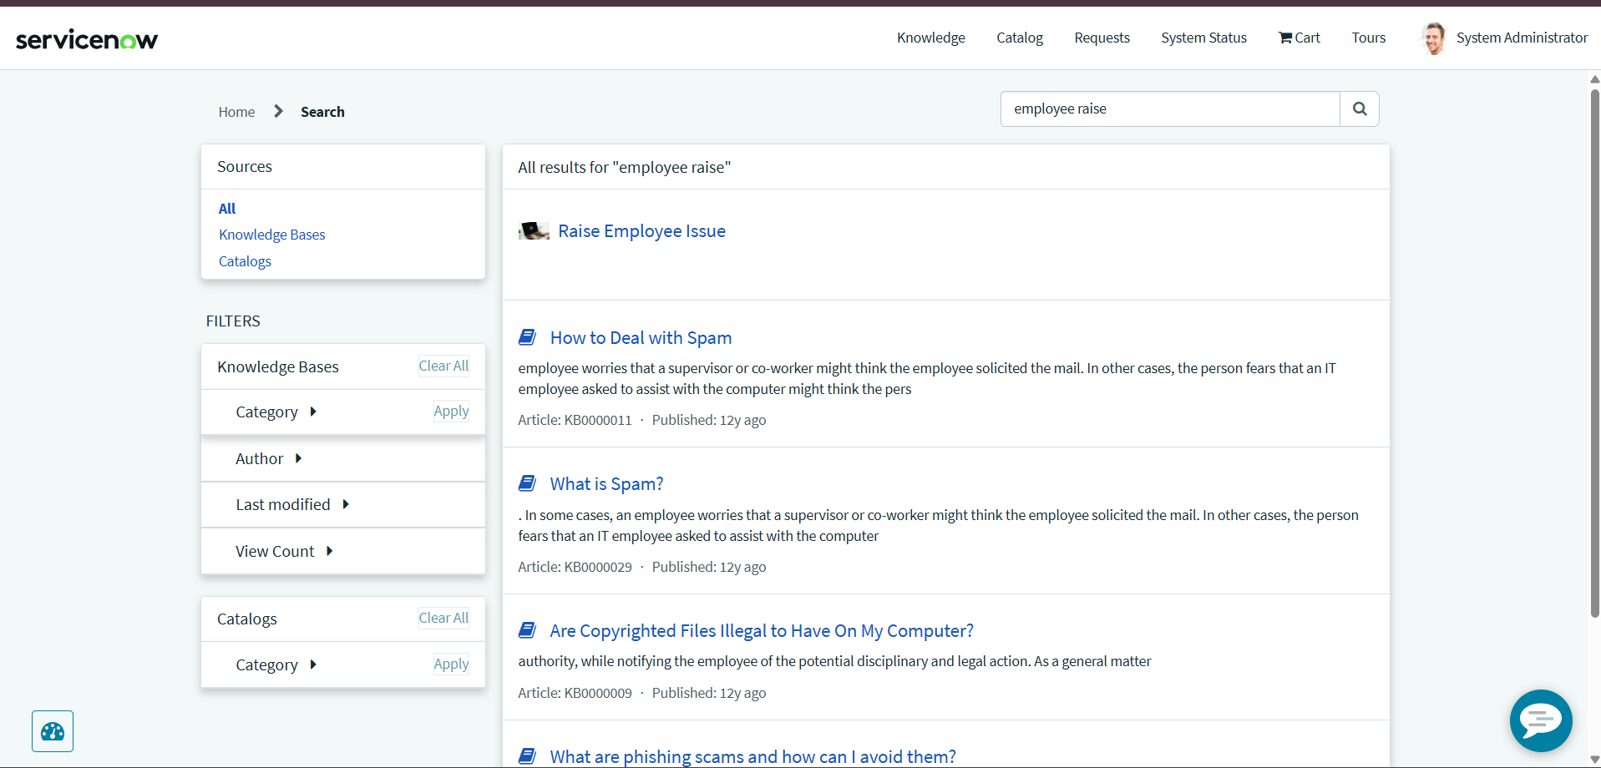
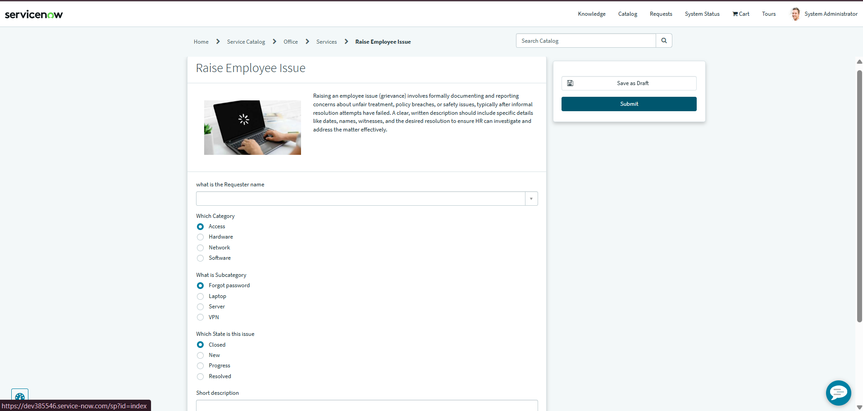

6. Result
The Record Producer provides a simple employee-facing request form and automatically creates a corresponding backend record.

